National Textile University, Faisalabad

Department of Computer Science

Project documentation
ESP32 Smart Radar System( Web Server + Blynk)
Group name :
Yudhra
Group members:
- M.UMAR MUSHTAQ (23-NTU-CS-1077)
- M.HAMZA FAISAL (23-NTU-CS-1066)
- M.ABDULLAH (23-NTU-CS-1056)

1️⃣ INTRODUCTION
In today’s modern security and monitoring systems, object detection and distance measurement play a vital role. Radar-based systems are widely used in ships, submarines, military surveillance, and industrial automation for detecting obstacles and nearby objects.
This project presents an ESP32-based Smart Radar System that uses an ultrasonic sensor and servo motor to perform scanning, detects objects in real time, and displays the results using:
- Web-based Radar Interface (Browser)
- Blynk IoT Mobile Application
- OLED Display & LED Alerts
The system combines embedded systems, IoT, and web technologies to provide real-time visualization and control.
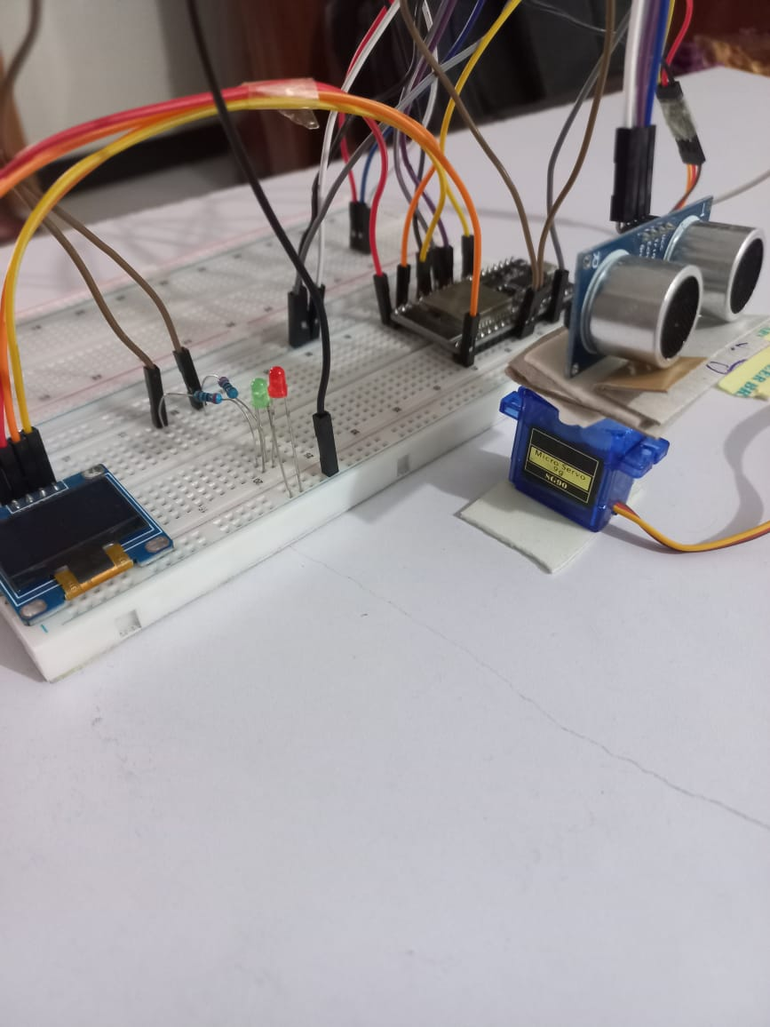

2️⃣ OBJECTIVES OF THE PROJECT
The main objectives of this project are:
- To design a low-cost radar system using ESP32
- To detect nearby objects and measure their distance.
- To visualize radar scanning in real time on a web browser
- To control the system remotely using Blynk mobile app
- To provide visual alerts using LEDs and OLED display

3️⃣ HARDWARE COMPONENTS USED
Component | Description
ESP32 | Main microcontroller with Wi-Fi
Ultrasonic Sensor (HC-SR04) | Measures object distance
Servo Motor | Rotates sensor (0°–180° sweep)
OLED Display (SSD1306) | Displays system status
Red & Green LEDs | Warning indicators
Resistors (220ohm)
Jumper wires

4️⃣ SYSTEM ARCHITECTURE
The system is divided into three major layers:
- Sensing Layer
  - Ultrasonic sensor measures distance
  - Servo motor performs radar sweep.
- Processing Layer
  - ESP32 processes sensor data
  - Calculates angle and distance.
  - Controls LEDs and OLED
- Application Layer
  - Web-based radar visualization
  - Blynk mobile app control
BLOCK DIAGRAM :
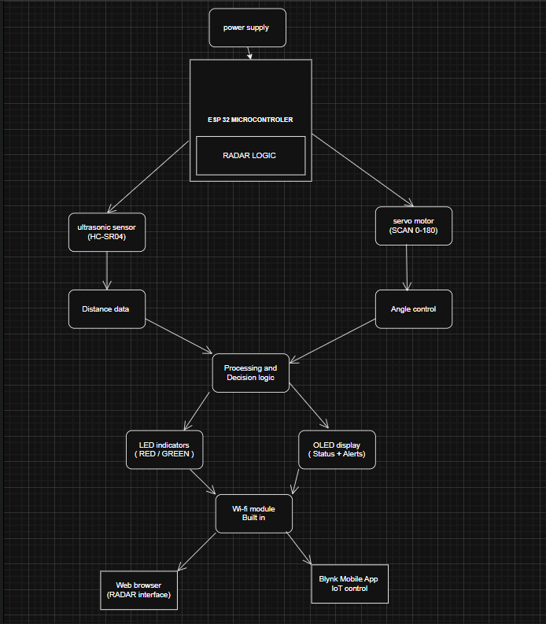

5️⃣ WORKING PRINCIPLE
- The servo motor rotates the ultrasonic sensor from 0° to 180°.
- At each angle:
  - Ultrasonic sensor sends sound waves.
  - Echo time is measured.
  - Distance is calculated in centimetres.
- ESP32:
  - Updates LEDs based on distance
  - Displays data on OLED.
  - Sends live data to web server.
- Web browser:
  - Shows circular radar.
  - Displays moving sweep line.
  - Shows detected object as red dot.
- Blynk app:
  - Allows ON/OFF control.
  - Enables automation and remote monitoring.

6️⃣ WEB-BASED RADAR SYSTEM
6.1 Web Server Configuration
ESP32 hosts a local web server on port 80 using the Webserver library.
Key endpoints:
- / → Radar UI page
- /toggle → Radar ON/OFF
- /speed → Servo speed control
- /data → JSON data (angle, distance, LED status)
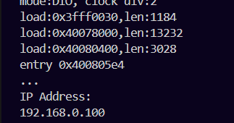
6.2 Radar Web Interface Design
The radar UI is built using:
- HTML
- CSS
- JavaScript
- Canvas API
Radar Features:
- Circular radar screen
- Distance rings
- Cross reference lines
- Green rotating sweep line
- Red dot for detected object
- Live warning messages
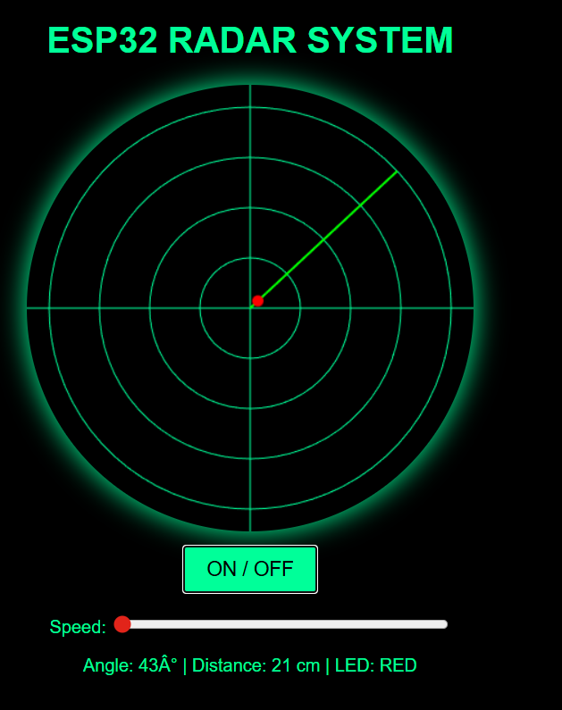
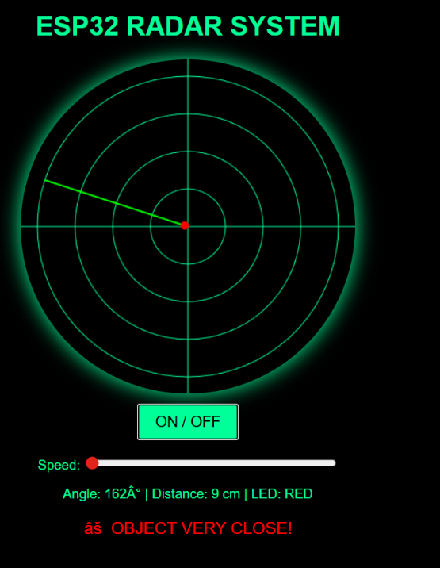
6.3 Real-Time Data Communication
ESP32 sends live data in JSON format:
{
"angle": 90,
"dist": 25,
"led": "RED"
}
JavaScript fetches this data every few milliseconds and updates:
- Radar sweep angle
- Object position
- Warning alerts

7️⃣ BLYNK IOT INTEGRATION
7.1 Blynk Platform Overview
Blynk is an IoT platform that allows remote device control using mobile applications.
In this project, Blynk is used to:
- Control radar ON/OFF
- Monitor device online status.
- Enable automation features.
- Show real time distance through chart and numeric value.
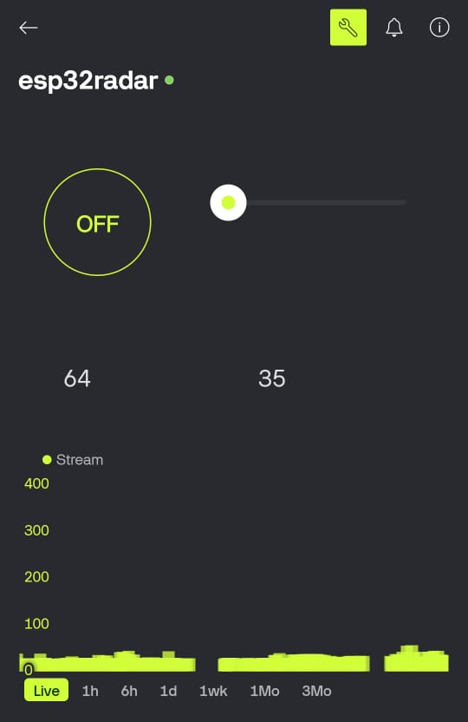
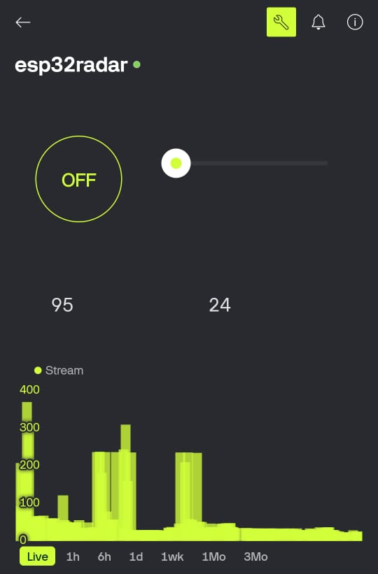
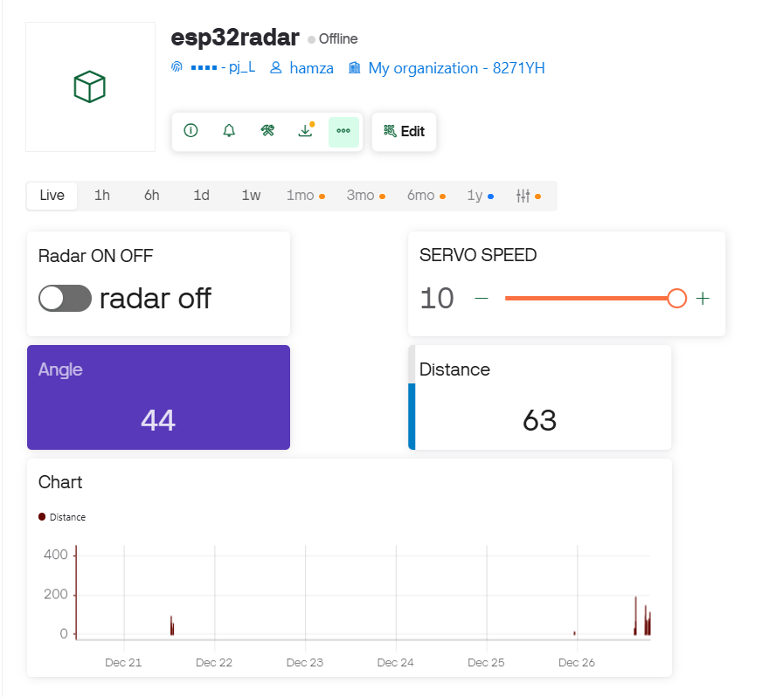

7.2 Blynk Functionalities Used
- Virtual buttons for control
- Cloud connectivity
- Real-time device status
- Future expansion for notifications
- Real time distance chart

8️⃣ ALERT & DISPLAY SYSTEM
8.1 LED Alert Logic
Distance | LED Status
< 40 cm | Red LED ON
≥ 40 cm | Green LED ON
8.2 OLED Display Information
OLED shows:
- Radar ON/OFF
- Servo angle
- Distance (cm)
- LED status
- Warning message
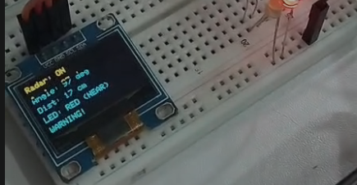

9️⃣ RESULTS AND OUTPUT
The system successfully:
- Detects objects accurately.
- Displays radar scan in real time.
- Provides web-based visualization.
- Allows mobile app control.
- Generates alerts for close objects.
FOR NEAR OBJECT VERY CLOSE:
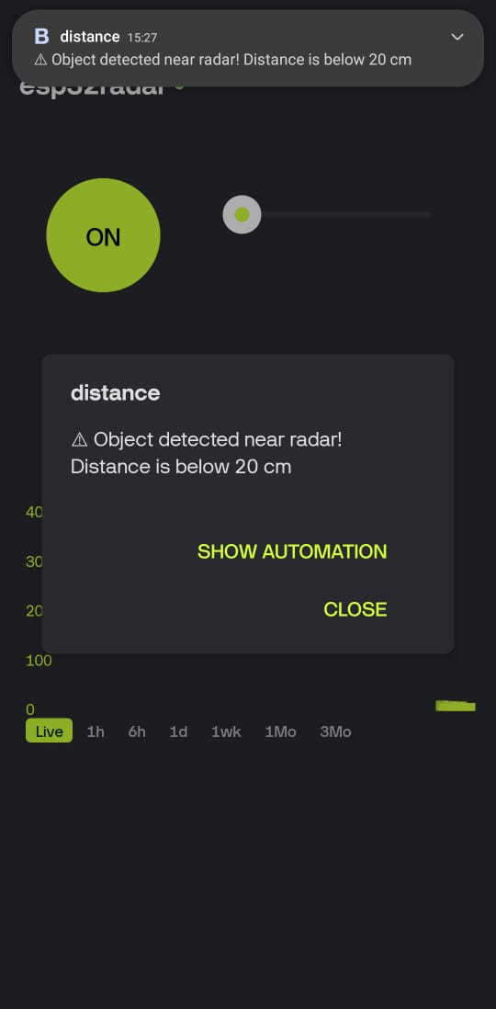
FOR FAR AWAY:
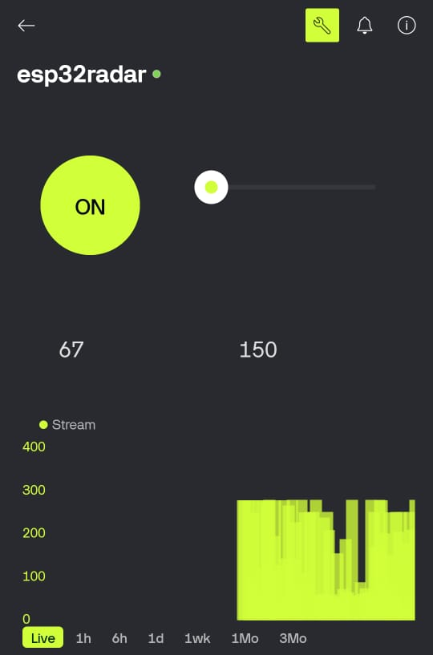

🔟 ADVANTAGES
- Low cost and easy to implement.
- Real-time monitoring
- Remote access via web and mobile
- Expandable for future features
- Educational and industrial use

1️⃣1️⃣ APPLICATIONS
- Ship and submarine navigation (simulation)
- Obstacle detection systems
- Smart surveillance
- Robotics
- Industrial safety monitoring

1️⃣2️⃣ FUTURE ENHANCEMENTS
- Cloud data logging
- Email / push notifications.
- Camera-based object detection
- AI-based object classification
- Mobile radar visualization

1️⃣3️⃣ CONCLUSION
This project successfully demonstrates an ESP32-based smart radar system with real-time web visualization and mobile IoT control. The integration of embedded hardware, web technologies, and IoT platforms makes the system efficient, scalable, and suitable for modern monitoring applications.

🔧 10. SOFTWARE DESIGN & CODE EXPLANATION

10.1 WEB-BASED RADAR SYSTEM – CODE EXPLANATION (WITH KEY CODE)

10.1.1 Libraries Used
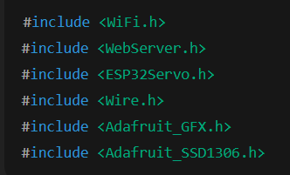Explanation
- WiFi.h
Enables the ESP32 to connect to a wireless network.
- WebServer.h
Allows the ESP32 to act as an HTTP web server.
- ESP32Servo.h
Used to control the servo motor for radar scanning motion.
- Wire.h
Provides I2C communication support for the OLED display.
- Adafruit_GFX.h & Adafruit_SSD1306.h
Used for rendering text and graphics on the OLED screen.
Purpose
These libraries collectively allow sensor interfacing, servo control, web hosting, and OLED visualization within a single embedded system.

10.1.2 Pin Configuration & Hardware Mapping
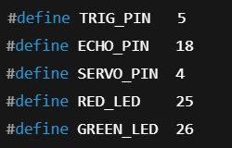Explanation
- TRIG_PIN & ECHO_PIN are connected to the ultrasonic sensor.
- SERVO_PIN controls the servo motor using PWM.
- RED_LED & GREEN_LED provide visual warning indications.
Importance
Clear pin mapping ensures reliable communication between the ESP32 and connected hardware components.

10.1.3 Radar Control Variables
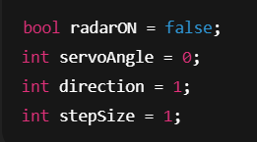
Explanation
- radarON controls whether the radar system is active.
- servoAngle stores the current scanning angle.
- direction controls left-to-right or right-to-left sweep.
- stepSize controls the speed of radar scanning.
Radar Logic
The servo motor continuously sweeps from 0° to 180° and back, simulating real radar behavior.

10.1.4 Ultrasonic Distance Measurement Logic
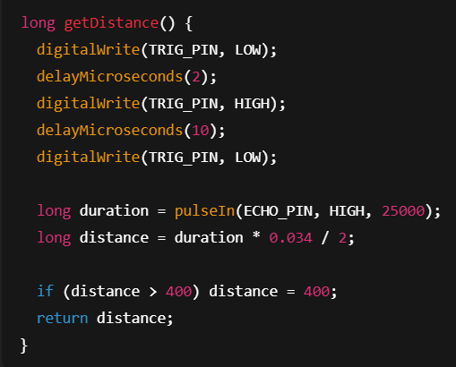
Explanation
- Ultrasonic pulse is transmitted using the TRIG pin.
- Echo time is measured via the ECHO pin.
- Distance is calculated using:
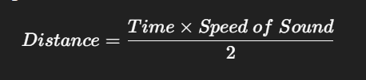
Limitation
Distance is capped at 400 cm to reduce noise and incorrect readings.

10.1.5 LED Warning Logic
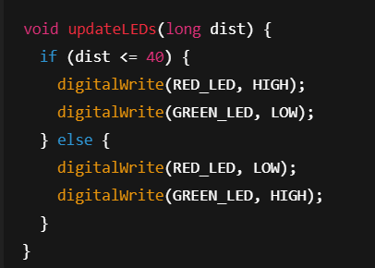
Explanation
- Red LED turns ON when an object is closer than 40 cm.
- Green LED remains ON when the distance is safe.
Purpose
Provides instant visual alerts for object proximity.

10.1.6 OLED Display Logic
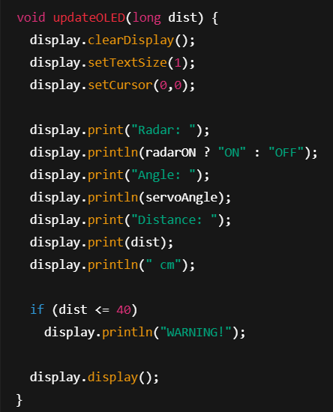
Explanation
The OLED displays:
- Radar ON/OFF status
- Current servo angle
- Measured distance
- Warning message for close objects

10.1.7 Web Server & API Routes
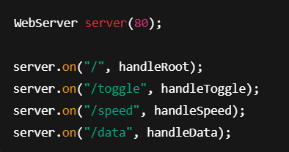Route Functions
Route | Description
/ | Loads radar web interface
/toggle | Turns radar ON/OFF
/speed | Controls scanning speed
/data | Sends live JSON data
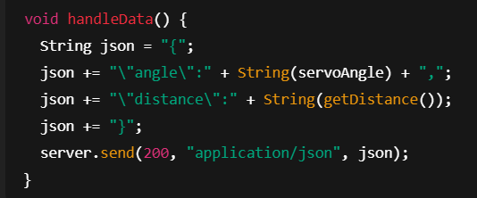
Purpose
Enables real-time data transfer between ESP32 and the web interface.

10.1.8 Radar Web Interface (Frontend Logic)
(JavaScript – Conceptual Overview)
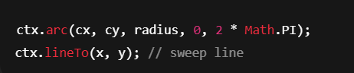Explanation
- Radar screen drawn using Canvas API
- Rotating sweep line synchronized with servo angle.
- Detected objects shown as red dots.

10.2 BLYNK-BASED RADAR SYSTEM – CODE EXPLANATION

10.2.1 Blynk Configuration
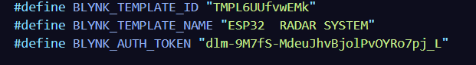Explanation
Authenticates ESP32 with the Blynk cloud for secure remote access.

10.2.2 Virtual Pins Usage
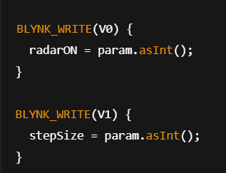
Virtual Pin | Function
V0 | Radar ON/OFF
V1 | Servo speed
V2 | Angle display
V3 | Distance display

10.2.3 Radar Task Function (Core Logic)
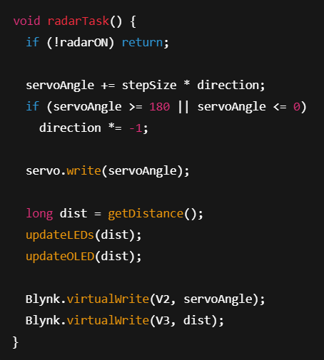
Explanation
This function performs:
- Servo scanning
- Distance calculation
- LED & OLED update
- Live Blynk data transmission

10.2.4 Blynk Timer & Main Loop
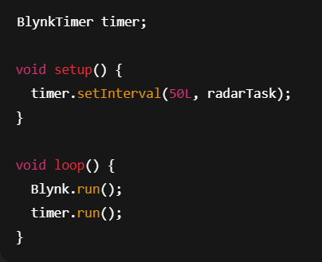
Explanation
- Radar task executes every 50 ms
- Ensures smooth scanning and stable cloud connection.

Screenshots of ALL:
